SIMATS ENGINEERING
Department of Computer Science & Engineering ASSESSMENT TOOL 1- ANALYTICAL PROBLEM SOLVING
Course Code: | CSA1202 | Course Title: | Computer Architecture
CO Assessed: | CO2 | Assessment: | ASSESSMENT TOOL1-  ANALYTICAL PROBLEM SOLVING
Weightage: | 45% | Total Marks: | 25
CO2 Statement: | Apply integer and floating-point arithmetic algorithms including Booth's multiplication, restoring/non-restoring division, and IEEE 754 standard operations to solve fixed-point and floating-point computational problems. (BL3)
Student Name: | Shailaja S | Reg.No.: | 192511026
Department: | BE CSE | Date: | 27/07/2026

Code of Conduct:
I SHAILAJA S (192511026) (Name / Reg No) certify that this submission is my original work and that I have adhered to the guidelines specified for this assessment. I understand that any violation of academic integrity rules will result in disciplinary action.
Signature of the student:

ANNEXURE A
1. A processor performs arithmetic operations on signed 8-bit integers using 2’s complement representation. Consider two numbers: +45 and −23. Analyze in detail how the system performs both addition and subtraction, including binary conversion, alignment of sign bits, and intermediate steps. Determine whether overflow occurs, and explain how the processor detects overflow and interprets the final result.
2. A high-performance computing system replaces a ripple carry adder with a 4-bit carry look ahead adder (CLA) to reduce computation delay. Given two binary inputs, analyze how generate and propagate signals are formed and how carries are computed in advance. Compare the time delay of CLA with ripple carry addition and justify, with reasoning, why CLA improves speed in modern processors.
3. In a signed multiplication operation, a processor uses Booth’s algorithm to multiply two numbers, −6 and +5. Analyze the algorithm step-by-step, including the role of the accumulator, multiplier, and Booth bit, along with arithmetic shifts. Explain how the algorithm efficiently handles signed numbers and reduces the number of addition/subtraction operations compared to traditional multiplication.
4. A processor is required to perform division of two binary numbers (e.g., 13 ÷ 3) using both restoring and non-restoring division algorithms. Analyze both methods step-by-step, showing intermediate remainders and quotient formation. Compare the two approaches in terms of number of steps, complexity, and efficiency, and explain why non-restoring division is often preferred in modern systems.
5. A scientific application requires precise handling of real numbers using the IEEE 754 standard for floating-point representation. Given a decimal number (e.g., −13.25), analyze how it is represented in both single precision and double precision formats, including sign, exponent, and mantissa fields. Further, explain how floating-point addition is performed between two such numbers, highlighting issues like normalization, rounding, and precision loss.

1) Binary Conversion:
+45 = 00101101
−23: 23 = 00010111 → 1’s comp = 11101000 → +1 = 11101001
00010110 = 22
No overflow (operands have different signs).
Subtraction:
(+45) − (−23)
= (+45) + (+23)
01000100 = 68
No overflow (result within −128 to +127).
Overflow Detection:
Overflow occurs if:
- Same sign inputs → different sign output
- Carry into MSB ≠ carry out
Here, no overflow in both cases.

Final result:
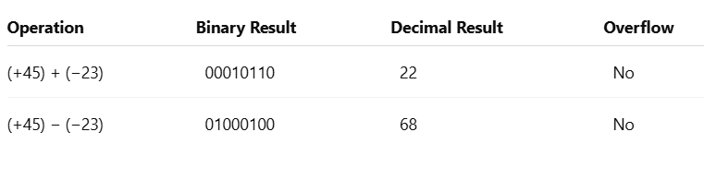
2) 1. Generate and Propagate Signals:
For each bit i:
- Generate: ( G_i = A_i \cdot B_i ) (carry generated)
- Propagate: ( P_i = A_i \oplus B_i ) (carry propagated)
2. Carry Computation (4-bit CLA):
Using input carry ( C_0 ):
- ( C_1 = G_0 + P_0 C_0 )
- ( C_2 = G_1 + P_1 G_0 + P_1 P_0 C_0 )
- ( C_3 = G_2 + P_2 G_1 + P_2 P_1 G_0 + P_2 P_1 P_0 C_0 )
- ( C_4 = G_3 + P_3 G_2 + P_3 P_2 G_1 + P_3 P_2 P_1 G_0 + P_3 P_2 P_1 P_0 C_0 )
Thus, all carries are computed simultaneously.
3. Time Delay Comparison:
- Ripple Carry Adder: Delay increases linearly (carry propagates bit by bit) → O(n)
- CLA: Carries computed in parallel → O(1) (constant delay for small bits)
4. Reason for Speed Improvement:
CLA reduces waiting time by avoiding sequential carry propagation. All carries are pre-calculated using logic expressions, making it much faster.
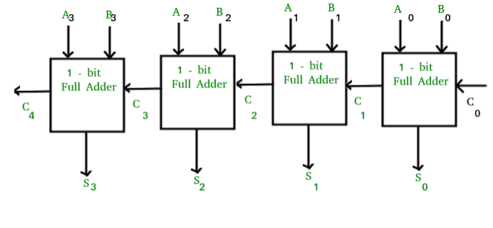

3) Given:
Multiplicand (M) = −6 → 11111010
Multiplier (Q) = +5 → 00000101
Initialize: Accumulator (A) = 00000000, Booth bit (Q₋₁) = 0
1. Working Principle:
Check last bit of Q and Q₋₁:
- 10 → A = A − M
- 01 → A = A + M
- 00 or 11 → No operation
After each step → perform arithmetic right shift (A, Q, Q₋₁)
2. Step-by-Step Process (Summary):
- Step 1: Q₀Q₋₁ = 10 → A = A − M
- Step 2: Shift right
- Step 3: Q₀Q₋₁ = 01 → A = A + M
- Step 4: Shift right
- Continue for 8 cycles
Final result stored in (A,Q)
3. Final Result:
−6 × 5 = −30
Binary result = 11100010 (2’s complement of 30)
4. Role of Components:
- Accumulator (A): Stores partial results
- Multiplier (Q): Holds multiplier bits
- Booth bit (Q₋₁): Helps decide add/subtract operation
5. Advantages of Booth’s Algorithm:
- Handles signed numbers directly
- Reduces number of additions/subtractions
- Efficient for sequences of 1’s in multiplier
- Faster than traditional multiplication
4) Given:
Dividend = 13 → 1101
Divisor = 3 → 0011
1. Restoring Division (Concept & Steps):
- Subtract divisor from remainder
- If result ≥ 0 → quotient bit = 1
- If result < 0 → restore (add divisor back), quotient bit = 0
Final Result:
Quotient = 0100 (4)
Remainder = 0001 (1)
2. Non-Restoring Division (Concept & Steps):
- Avoid restoring step
- If remainder ≥ 0 → subtract divisor
- If remainder < 0 → add divisor in next step
Final Result:
Quotient = 0100 (4)
Remainder = 0001 (1)
3. Reason for Preference:
Non-restoring division eliminates the restoration step, reducing operations and improving speed. Hence, it is preferred in modern processors.

4.comparison:
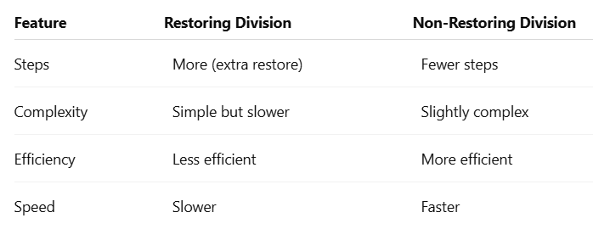
5) Given Number: −13.25
1. Binary Conversion:
13.25 = 1101.01₂
Normalize: (1.10101 × 2^3)
2. Single Precision (32-bit):
- Sign bit (S) = 1 (negative)
- Exponent (E) = 3 + 127 = 130 → 10000010
- Mantissa (M) = 10101000000000000000000
Representation:
1 | 10000010 | 10101000000000000000000
3. Double Precision (64-bit):
- Sign bit (S) = 1
- Exponent (E) = 3 + 1023 = 1026 → 10000000010
- Mantissa (M) = 1010100000000000000000000000000000000000000000000000
Representation:
1 | 10000000010 | 101010…(52 bits)
4. Floating-Point Addition (Concept):
Steps:
- Align exponents (shift smaller number)
- Add/Subtract mantissas
- Normalize result
- Round to fit mantissa bits
5. Important Issues:
- Normalization: Ensures format (1.x × 2^n)
- Rounding: Needed due to limited bits
- Precision Loss: Small differences may be lost during alignment
- Overflow/Underflow: When exponent exceeds range

RUBRICS FOR CALCULATION:
Criteria | Weightage | Level 4 – Exemplary | Level 3 –  Proficient | Level 2 –  Developing | Level 1 –  Beginning
Problem  Understanding | 20% | Clearly interprets  problem, identifies all parameters and  requirements accurately | Understands  problem with  minor gaps | Partial  understanding;  misses key  elements | Misinterprets or unable to  understand  problem
Method Selection | 20% | Selects most appropriate method/formula with strong justification | Selects correct  method with  minor errors | Inappropriate or  partially correct  method | Unable to select method
Solution Process | 25% | Logical, systematic  steps with correct  approach throughout | Mostly correct  steps with minor mistakes | Disorganized steps; multiple errors | No clear process
Accuracy of  Calculation | 20% | All calculations  accurate; correct final answer | Minor calculation errors | Frequent errors;  incorrect final  answer | No valid  calculations
Interpretation of Results | 15% | Clearly interprets results with units and  engineering relevance | Basic  interpretation with minor omissions | Limited or unclear interpretation | No interpretation

